# Ideation Phase

Define the problem statements

|  |  |
| --- | --- |
| NM_ID | BF65628C5F4C176991E4180F64CA6B6F |
| Project name | How To Create Brand Name, Brand Mail And Brand Logo In Canva |

The problem statement should clarify the boundaries or limits of the problem, explaining what is and isn't included. This helps to focus efforts on the most relevant aspects.

A problem statement is a concise, clear, and well-defined description of an issue or challenge that needs to be addressed. It serves as the foundation for problem-solving, project planning, and decision-making.

# Definition of problem diagram

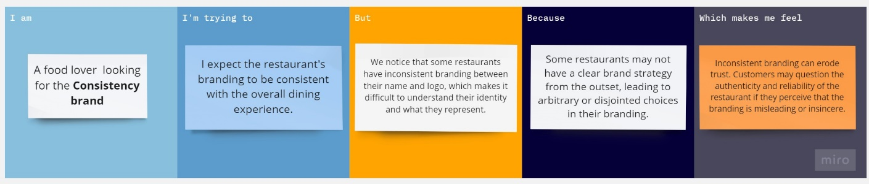

Reference link: https://miro.com/app/board/uXjVNTF4sh4=/

|  |  |  |  |  |  |
| --- | --- | --- | --- | --- | --- |
| Problem statement | I am | I’m trying  to | But | Because | Which  make me feel |
| PS | A food lover  looking for the **Consistency brand.** | I expect the restaurant's branding to be consistent with the overall dining experience. | We notice that some restaurants have inconsistent branding between their name and logo, which makes it difficult to understand their identity and what they represent. | Some restaurants may not have a clear brand strategy from the outset, leading to arbitrary or disjointed choices in their branding. | Inconsistent branding can erode trust. Customers may question the authenticity and reliability of the restaurant if they perceive that the branding is misleading or insincere. |